Numbers – Activity 1 Questions
Read this information about understanding and using numbers up to 20.

Numbers
Each single number is known as a digit.
Numbers tell us how many of an object there is. e.g. Ben has two (2) dogs.
Numbers can be written in words and number as seen in the table below:
Number | Word | Number | Word | Number | Word
0 | Zero | 7 | Seven | 14 | Fourteen
1 | One | 8 | Eight | 15 | Fifteen
2 | Two | 9 | Nine | 16 | Sixteen
3 | Three | 10 | Ten | 17 | Seventeen
4 | Four | 11 | Eleven | 18 | Eighteen
5 | Five | 12 | Twelve | 19 | Nineteen
6 | Six | 13 | Thirteen | 20 | Twenty

Numbers can be ordered, for example, 6 is greater than or comes after 5. It is also less than or comes before 7.
These are the numbers 0 - 20 in order from smallest to biggest:

0 1 2 3 4 5 6 7 8 9 10 11 12 13 14 15 16 17 18 19 20

These are the same numbers but in order from biggest to smallest:

20 19 18 17 16 15 14 13 12 11 10 9 8 7 6 5 4 2 1 0

You might have to count how many people there are if you are ordering some pizzas so that you make sure everyone gets a pizza.
You could count how many cups of tea are needed for the office at tea break.

Addition and Subtraction

You might have to do some calculations using numbers, such as addition and subtraction.
We use these symbols
+ (add) for addition
– (minus) for subtraction
= (equals)

Addition means adding the numbers to each other to get a bigger number, e.g.:
3 + 12 =15
4 + 2 = 6

Subtraction means taking one number from another to find a smaller number, e.g.:
14 – 6 = 8
8 – 6 = 2

Activity 1a.
Use the information you have read to answer these questions.ition and subtraction vityntry 1 Maths: Describe position

1. Sort these numbers from small to large:

4, 5, 2, 9 …………………………

19, 8, 13, 4 …………………………

7, 1, 6, 3 …………………………

2. Sort these numbers from large to small:

1, 7, 3, 9 …………………………

18, 2, 6, 14 …………………………

5, 7, 3, 4 …………………………
Learner resources Entry 1 Maths – Number – addition and subtraction

Activity 1b.
Use the information you have read to answer these questions.

1. What do the symbols below mean?

+ …………………. - …………………. = ……………………

Activity 1c.
Use the information you have read to answer these questions.

1. How many red squares are in the image below? ……………………………

2. How many green triangles are in the image below? ………………………..

3. How many shapes are there altogether? …………………………………….

E1 Math

Activity 1d.
Find the answers to these addition calculations.

1. 6 + 4 = ……….

2. 17 + 2 = ……….

3. 1 + 6 = ……….

4. 4 + 14 = ……….

5. 15 + 5 = ……….

Activity 1e.
Find the answers to these subtraction calculations.

1. 9 – 2 = ………

2. 5 – 3 = ………

3. 6 – 5 = ………

4. 17 – 1 = ………

5. 13 – 3 = ………

Activity 1f.
Find the answers to these calculations.
1. Jess needs 3 eggs to make a cake. She decides to make 2 cakes. How many eggs would she need altogether?

………………………………………………………………………………………………………………

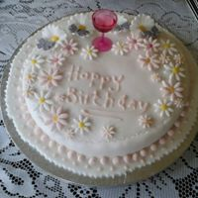
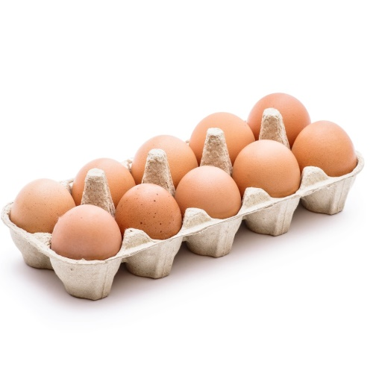
2. Jess had a box of 10 eggs and she used these to make the cakes. How many eggs would she have left in the box?

………………………………………………………………………………………………………………

Now check your answers for these activities.

Entry

